
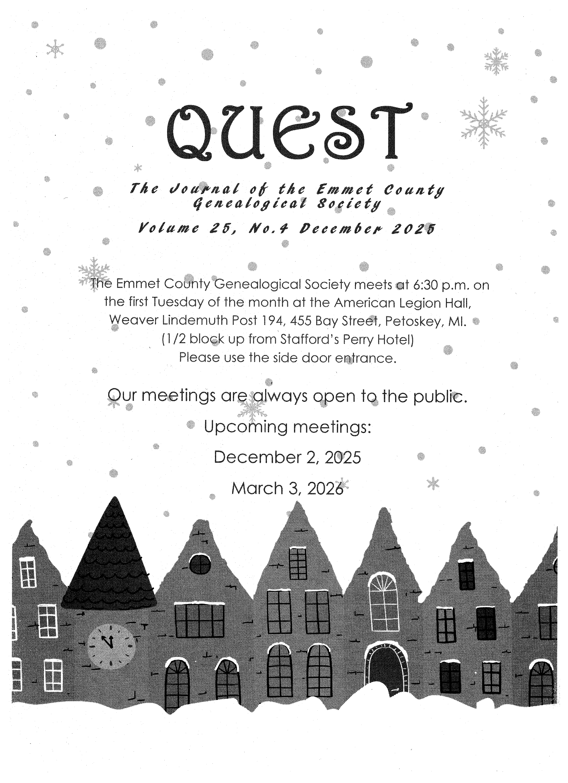

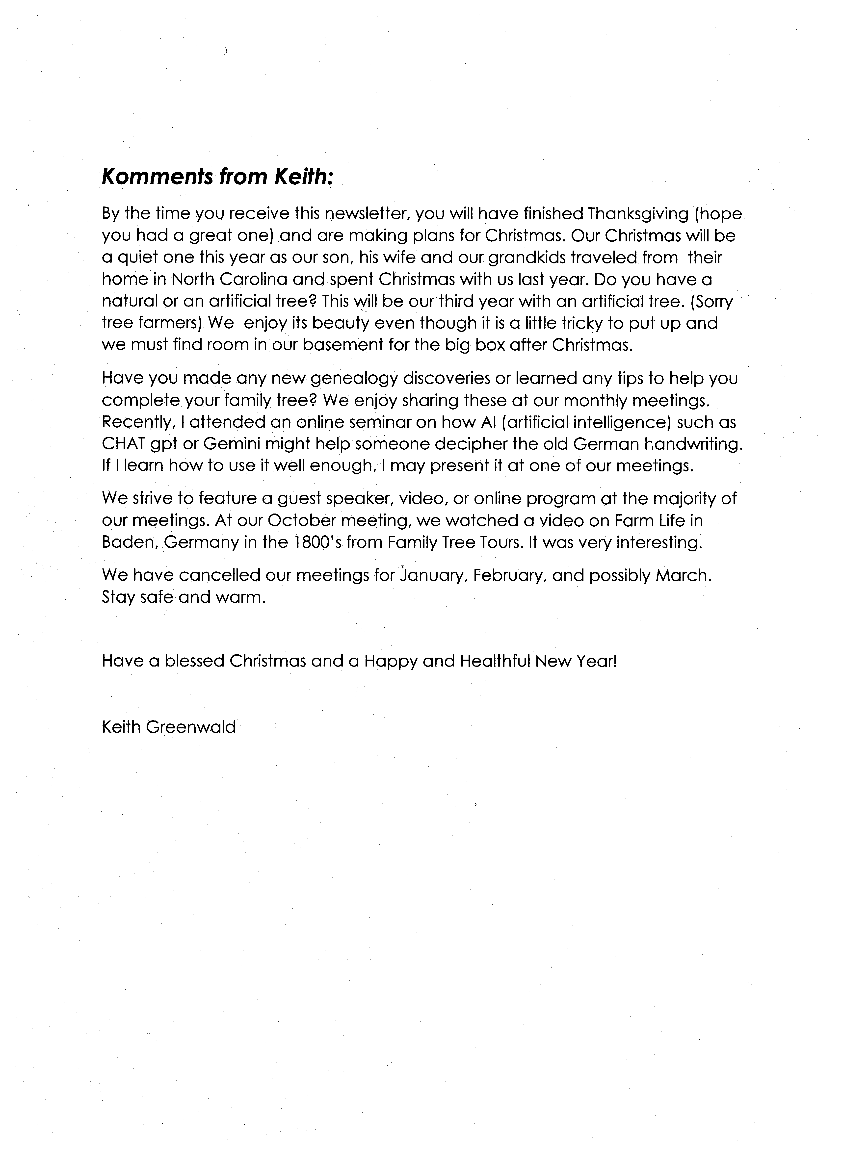
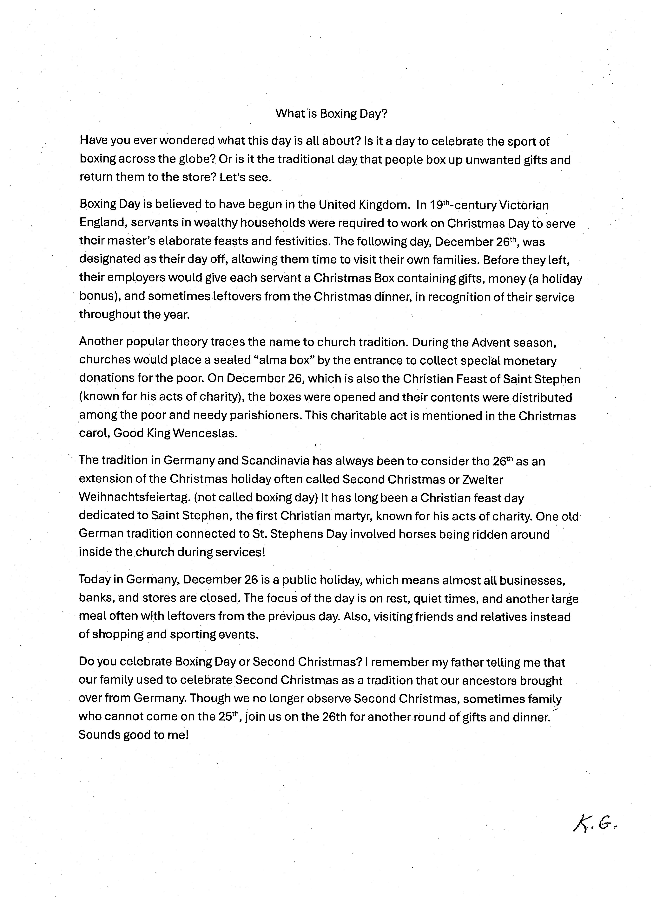

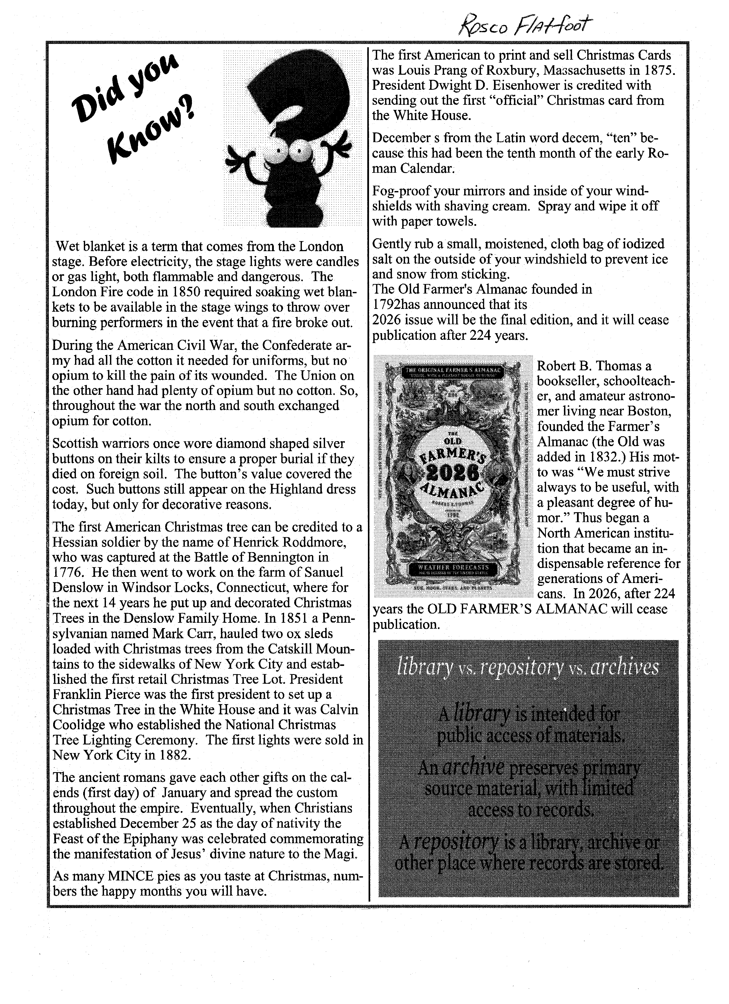

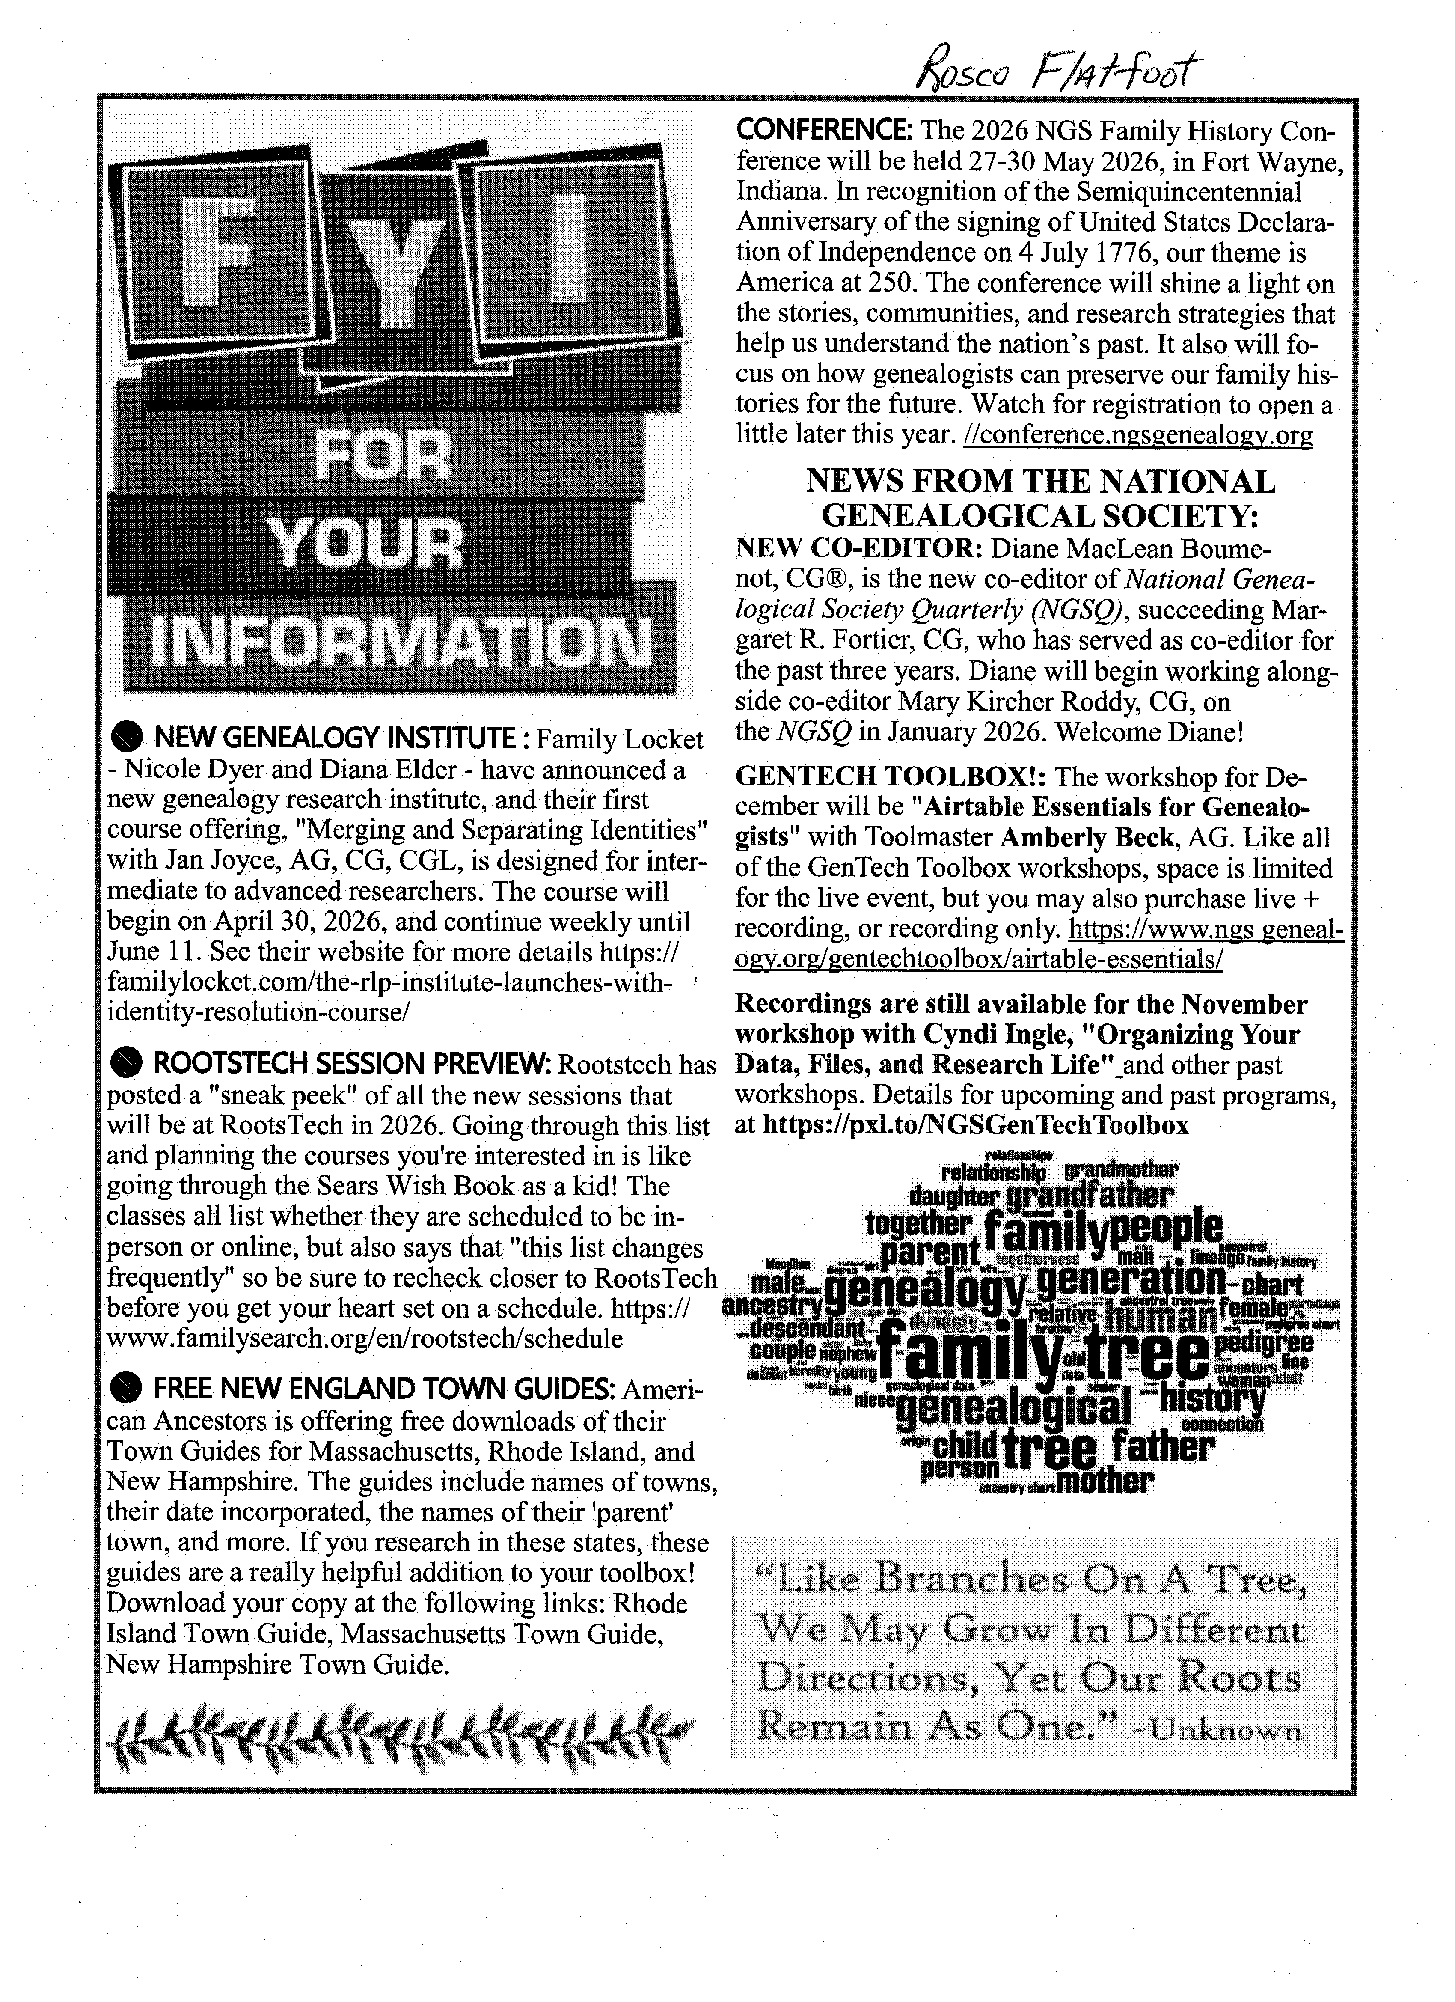

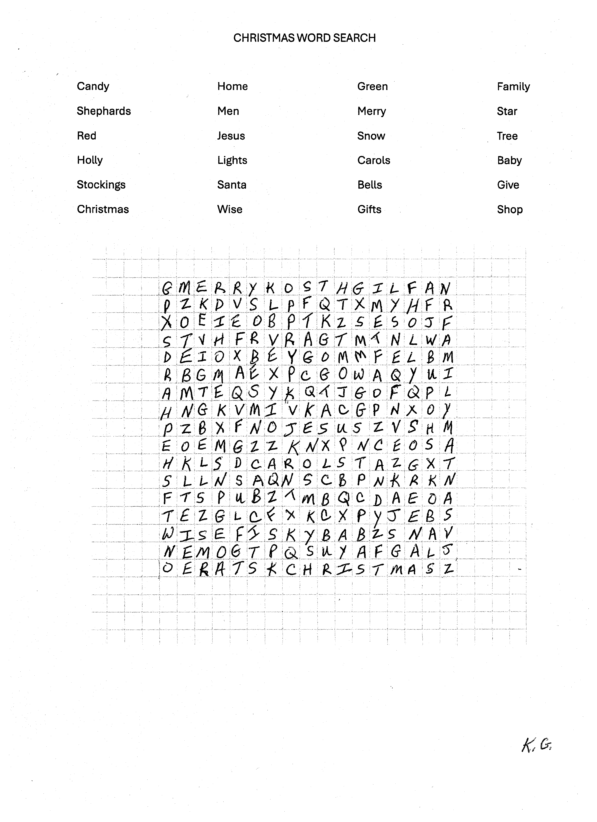

Komments from Keith:
By the time you receive this newsletter, you will have finished Thanksgiving (hope you had a great one) and are making plans for Christmas. Our Christmas will be a quiet one this year as our son, his wife and our grandkids traveled from their home in North Carolina and spent Christmas with us last year. Do you have a natural or an artificial tree? This will be our third year with an artificial tree. (Sorry tree farmers) We enjoy its beauty even though it is a little tricky to put up and we must find room in our basement for the big box after Christmas.
Have you made any new genealogy discoveries or learned any tips to help you complete your family tree? We enjoy sharing these at our monthly meetings. Recently, I attended an online seminar on how AI (artificial intelligence) such as CHAT gpt or Gemini might help someone decipher the old German handwriting. If I learn how to use it well enough, I may present it at one of our meetings.
We strive to feature a guest speaker, video, or online program at the majority of our meetings. At our October meeting, we watched a video on Farm Life in Baden, Germany in the 1800’s from Family Tree Tours. It was very interesting.
We have cancelled our meetings for January, February, and possibly March. Stay safe and warm.

Have a blessed Christmas and a Happy and Healthful New Year!

Keith Greenwald

